**GENERAL INTEGRATED SCIENCE– UNIT 3**

**TASK 1 – Abiotic Factors Practical**

**NAME: _____________________________________ WEIGHTING: 8 %**

**Part One: /33**

**Part Two /tba**

Your task is to conduct and analyse the following inquiry. This is a long-term investigation in which you will monitor the growth of pond weed and moneywort to determine which abiotic factor has the greatest impact on its growth. You will need to include a reference list for any research you complete.

Abiotic factors are the non-living aspects of an ecosystem, and include salinity, pH, light, nitrate levels, phosphate levels, dissolved oxygen, temperature and water.

In combination with biotic factors, abiotic factors impact the overall health and sustainability of an ecosystem. But what impact, one asks, do particular abiotic factors have on the growth of a specific organism? Is there one abiotic factor that is more important than all of the others?

***Aim****: to determine which abiotic factor; light, temperature, water acidity or water mineral content has the biggest effect on plant growth*

Over the next several weeks of the term, you are going to be collecting data to meet this aim. Before you can begin, however, you must complete some basic research so that you can write a reasonable hypothesis.

1. **Complete foundation research on moneywort and the species of pond weed, the ecosystems and countries they are normally found in, and the type of abiotic conditions they thrive in.** *(5 marks)*

Now that you have a decent understanding of the plants and the abiotic factors they prefer, you can write a strong hypothesis.

1. **Hypothesis: (3 marks)**

_____________________________________________________________________________________________________________________________________________________________________________________________________________________________________________________________________________________________________________________________________________________________________________

1. **Using two pieces of information from your research, justify your hypothesis: (2 marks)**

______________________________________________________________________________________________________________________________________________________________________________________________________________________________________________________________________________________________________________________________________________________________

It is now time to commence the research. A high quality scientific inquiry has very clearly stated variables. Outline your variables below.

1. **Independent variables**: (4 marks) ________________________________________________________________________________________________________________________________________________________________________________________________________________________________________________________________________________________
2. **Dependent variable**: (1 mark)

______________________________________________________________________

To be a fair test, an experiment must have controlled variables. In the space below, you need to list at least SIX variables that were controlled during this experiment. Remember, only the independent variable was changed, so everything else in the organism’s life must remain the same.

1. **Controlled variables** *(3 marks)* ______________________________________________________________________________________________________________________________________________________________________________________________________________________________________________________________________________________________________________________________________________________________
2. **Explain what a control group is, and why it is important to include one in this kind of research** (3 marks)

________________________________________________________________________________________________________________________________________________________________________________________________________________________________________________________________________________________

**Materials:**

* Data logger
* Heat lamp
* Scales
* Spare bowl or tray
* Pipette
* Cloth or towel
* Water conditioner
* Sodium carbonate
* Vinegar
* Spoon

**Method.** *(3 marks)*

1. Take one set of pond weed
2. Weigh the pond weed and record the weight in your table

**The method from here is different for each group, as each group is in charge of a different tank with its own independent variable**

**Control condition**

1. Fill the tub with tap water
2. Put THREE drops of water conditioner into the water
3. Use a ruler to measure the height of the moneywort
4. Place both the pondweed and moneywort into the tub
5. Dry your area with a cloth or towel

**Tap water**

1. Fill the tub with tap water
2. Use a ruler to measure the height of the moneywort
3. Place both the pondweed and moneywort into the tub
4. Dry your area with a cloth or towel

**Distilled water**

1. Fill the tub with distilled water
2. Put THREE drops of water conditioner into the water
3. Use a ruler to measure the height of the moneywort
4. Place both the pondweed and moneywort into the tub
5. Dry your area with a cloth or towel

**Warm water**

1. Fill the tub with tap water, being careful not to jostle the plants too much
2. Put TWO drops of water conditioner into the water
3. Place both the pondweed and moneywort into the tub
4. Use a ruler to measure the height of the moneywort
5. Place under heat lamp and turn on
6. Dry your area with a cloth or towel

**Tap water with sodium carbonate (high alkaline)**

1. Fill the tub with tap water
2. Put TWO drops of water conditioner into the water
3. Put ONE spoon of sodium carbonate into the water and stir
4. Measure the PH (acidity) with the data logger. It should be near 11
5. Use a ruler to measure the height of the moneywort
6. Dry your area with a cloth or towel

**Tap water with vinegar (high acidity)**

1. Fill the tub with tap water
2. Put TWO drops of water conditioner into the water
3. Put ONE spoon of vinegar into the water and stir
4. Measure the PH (acidity). It should be near 4
5. Use a ruler to measure the height of the moneywort
6. Dry your area with a cloth or towel

**Low light**

1. Fill the tub with tap water, being careful not to jostle the plants too much
2. Put TWO drops of water conditioner into the water
3. Place both the pondweed and moneywort into the tub
4. Use a ruler to measure the height of the moneywort
5. Place under a counter
6. Dry your area with a cloth or towel

**Draw a diagram of the experiment.** Include all conditions and all tubs. Be sure to label everything

(3 marks)

|  |  |  |  |  |  |  |
| --- | --- | --- | --- | --- | --- | --- |
|  | **Weight of pond weed (grams)** | | | | | **Total increase in weight** |
| **Independent variable** | **Time one**  **Date:** | **Time two**  **Date:** | **Time three**  **Date:** | **Time four**  **Date:** | **Time five**  **Date:** |
| Control condition |  |  |  |  |  |  |
| Tap water |  |  |  |  |  |  |
| Distilled water |  |  |  |  |  |  |
| Warm water |  |  |  |  |  |  |
| High alkaline water |  |  |  |  |  |  |
| High acidity water |  |  |  |  |  |  |
| Low light |  |  |  |  |  |  |

|  |  |  |  |  |  |  |
| --- | --- | --- | --- | --- | --- | --- |
|  | **Height of moneywort (centimetres)** | | | | | **Total increase in height** |
| **Independent variable** | **Time one**  **Date:** | **Time two**  **Date:** | **Time three**  **Date:** | **Time four**  **Date:** | **Time five**  **Date:** |
| Control condition |  |  |  |  |  |  |
| Tap water |  |  |  |  |  |  |
| Distilled water |  |  |  |  |  |  |
| Warm water |  |  |  |  |  |  |
| High alkaline water |  |  |  |  |  |  |
| High acidity water |  |  |  |  |  |  |
| Low light |  |  |  |  |  |  |

(4 marks)

*(5 marks)*

*Spare graph on the next page. Indicate clearly if you are going to use this*



**TASK 1 – Abiotic Factors Practical**

**NAME: _____________________________________**

**Part One: /33 Part Two /25**

**Total: /58**

**Data Analysis**

1. **Describe any trends in your results by referring to the graph and table (4 marks)**

|  |
| --- |
|  |
|  |
|  |
|  |
|  |
|  |

The most exciting part about a scientific inquiry is that, once the investigation has been completed, you end up developing more questions than you answer.

1. **In the space below, construct one question that this data raises that we cannot answer with the information we currently have (1 mark)**

|  |
| --- |
|  |
|  |
|  |

1. **Every experiment has flaws. Describe TWO flaws that were present in this study**

**(2 marks)**

|  |
| --- |
|  |
|  |
|  |
|  |

1. **Explain how these TWO flaws made the results less accurate (2 marks)**

|  |
| --- |
|  |
|  |
|  |
|  |
|  |
|  |

1. **Additional organisms started growing in some tubs but not others. Explain why this occurred, referring to abiotic factors (2 marks)**

|  |
| --- |
|  |
|  |
|  |
|  |
|  |
|  |

1. **In this experiment, you almost entirely removed light from one of the tanks. What impact would you expect this abiotic change to have on a real ecosystem? (2 marks)**

|  |
| --- |
|  |
|  |
|  |
|  |
|  |
|  |

1. **Write a scientific conclusion for this experiment (2 marks)**

|  |
| --- |
|  |
|  |
|  |
|  |
|  |
|  |

1. 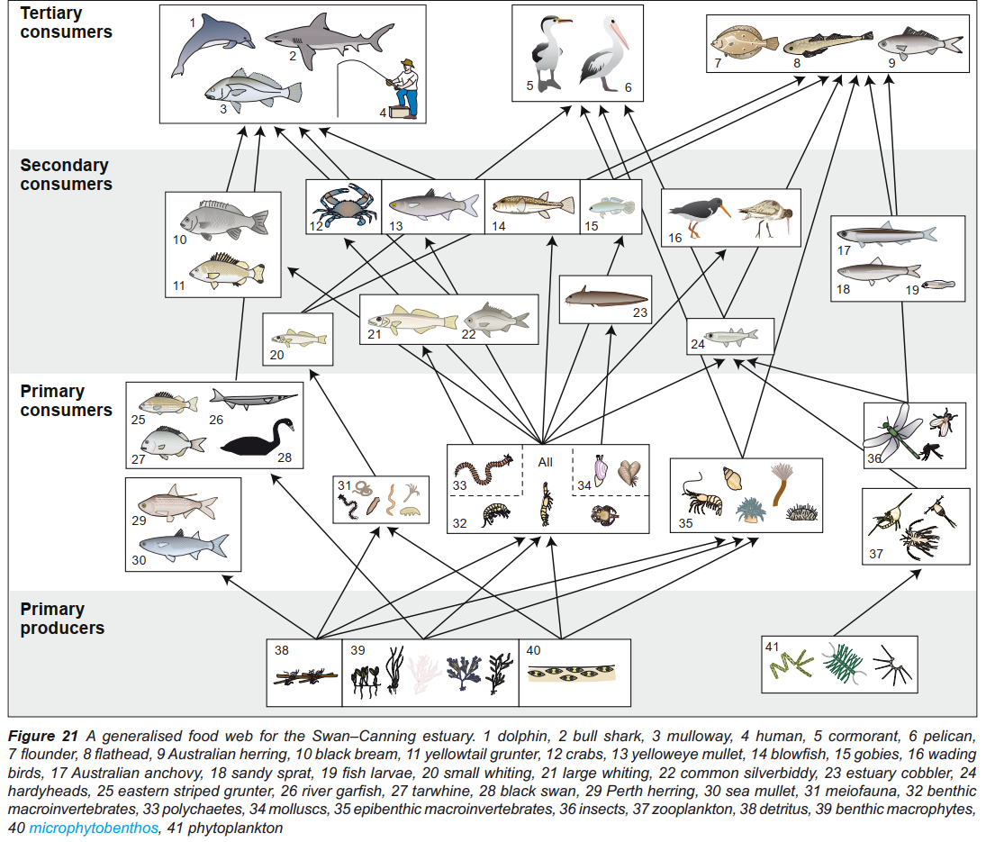**Sometimes substances from farms flow into rivers (this is called agricultural runoff) and make the water more acidic. This may occur in the Swan River. Below is a food web of this ecosystem.**
   1. **What do our results say about how this would affect plants in the Swan River?**

|  |
| --- |
|  |
|  |
|  |

**(1 mark)**

* 1. **Explain WHY increased acid levels in the water would reduce the populations of each of the below animals (8 marks)** 
     1. **Insects that live in the water**

|  |
| --- |
|  |
|  |
|  |

* + 1. **Crabs**

|  |
| --- |
|  |
|  |
|  |

* + 1. **Pelicans**

|  |
| --- |
|  |
|  |
|  |

* + 1. **Dolphins**

|  |
| --- |
|  |
|  |
|  |

* 1. **Would increasing the water acidity increase or decrease the biodiversity of the Swan River? (1 mark)**

|  |
| --- |
|  |